

**Key Investor Information**

This document provides you with key investor information about this Fund. It is not marketing material. The information is required by law to help you understand the nature and the risks of investing in this Fund. You are advised to read it so you can make an informed decision about whether to invest.

**Salar Fund (the Fund) a sub-fund of CQS Funds (Ireland) plc (the Company). The Manager is KBA Consulting Management Limited (the Manager).**

|  |  |
| --- | --- |
| Class E2 Acc GBP (ISIN:IE00B51ZKG48) | Class E2 Acc EUR (ISIN:IE00B520G822) |
| Class E2 Acc USD (ISIN:IE00B51ZK080) |  |

Objectives and Investment Policy

The Fund aims to generate positive returns and preserve capital principally by buying debt instruments that offer a yield but also the potential to convert to shares (convertible bonds). The Fund is actively managed and not managed with reference to a benchmark.

The Fund aims to achieve a return that exceeds SONIA.

The Fund has a global focus. The Fund invests in bonds, issued by corporate or governmental issuers, which are either Investment Grade or non-Investment Grade in developed and emerging market countries.

The Fund invests primarily in convertible bonds that are trading close to their fixed income value. These convertible bonds are less sensitive to share price movement and are more bond-like in their risk profile, offering protection if shares prices fall. If share prices rise, they can still participate in this rise as they become increasingly equity-like.

Any income less expenses earned by the Fund will not be distributed to investors but will be accumulated in the net asset value per share of the Fund instead.

The value of the Fund is calculated and published daily and investors can buy and/or sell shares on any day in which the banks are open for business in Dublin and London.

The Fund may, but is not obliged to, use equities to reduce risk and manage the Fund more effectively.

Financed derivative instruments (FDIs) may be used to achieve the investment objective and reduce risk or manage the Fund more effectively. This may include but is not limited to the use of FDIs to create a short equity position to reduce equity risk on long convertible bonds.

For full investment objective and investment policy details, as well as subscription and redemption policies please refer to the Prospectus.

* **Class Currency Risk**: Currency hedging may not be successful in mitigating the effects of exchange rate fluctuations on non-USD classes.
* **Emerging markets risk**: Emerging markets are likely to bear higher risk due to lower liquidity and possible lack of adequate financial, legal, social, political and economic structures, protection and stability as well as uncertain tax positions.
* **Operational risk**: Material losses to the Fund may arise as a result of human error, system and/or process failure, inadequate procedures or controls.
* **Exchange rate risk**: Changes in exchange rates may reduce or increase the value of non-USD denominated assets held by the Fund. Currency hedging may not be successful in mitigating such effects.
* **High-yield risk**: High-yield investments, meaning instruments which pay a high amount of income generally involve greater credit risk and sensitivity to economic developments, giving rise to greater price movement than lower yielding instruments.
* **Liquidity risk**: Convertible bonds are predominately traded on an over-the-counter market and may be subject to lower liquidity than the underlying equity securities.
* **Derivatives and leverage risk**: Certain Derivatives may introduce in leverage into the Fund which may result in losses greater than the amount originally invested in that Derivative.

A more detailed description of the risk factors that apply to the Fund is set out in the [Fund’s Prospectus](https://www.cqs.com/documents/funds/uscb/supporting-docs/prospectus-cqs-funds-ireland-plc-28.01.2022.pdf) and Supplement.

|  |  |  |  |  |  |  |  |  |  |  |  |  |  |  |  |  |  |  |  |  |  |  |  |  |  |  |  |  |  |
| --- | --- | --- | --- | --- | --- | --- | --- | --- | --- | --- | --- | --- | --- | --- | --- | --- | --- | --- | --- | --- | --- | --- | --- | --- | --- | --- | --- | --- | --- |
| |  |  |  |  |  |  |  |  |  |  | | --- | --- | --- | --- | --- | --- | --- | --- | --- | --- | | ***Lower Risk*** | | |  |  |  |  |  | ***Higher Risk*** | | | ***Typically lower rewards*** | | | | |  | ***Typically higher rewards*** | | | | | **1** | **2** | | **3** | **4** | **5** | **6** | | **7** | |

The Fund is categorised as a 4 for the purposes of this table due to its investments in convertible bonds and use of FDIs. This means that the Fund’s risk is normally higher than that of fixed income instruments but lower than that of equity instruments.

Like convertible bond and equity markets, the Fund may experience downward price movements from time to time. While the Fund seeks to reduce risk by investing in a diversified range of assets, such diversification does not eliminate risk.

The risk and reward indicator has been calculated using historic data and may not be a reliable indication of the future profile of the Fund.

The risk and reward category shown above is not guaranteed and may move up or down over time. The lowest category does not mean a risk free investment.

The Fund price may fall as well as rise and as a result you may not get back the original amount you invested.

**Other Material Risks**

* **Credit/Counterparty risk**: A party or issuer that the Fund transacts with may fail to meet its obligations which could cause losses.

Risk and Reward Profile

**Charges for this Fund**

|  |  |  |  |  |  |
| --- | --- | --- | --- | --- | --- |
| **One-off charges taken before or after you invest** | | | | | |
| **Entry Charge** | None |  | | **Exit Charge** | None |
| The Entry Charge is the maximum that might be taken out of your money before it is invested. | | | | | |
| **Charges taken from the fund over a year** | | | | | |
| **Ongoing charges** | | | 1.93% | | |
| **Charges taken from the fund under certain specific conditions** | | | | | |
| **Performance fee** | | | 10% over a high-water mark/hurdle  Hurdle: SONIA GBP for E2 GBP Shares, the Euro Short Term Rate for E2 EUR Shares and 90 day US LIBOR for E2 USD Shares | | |

The charges you pay are used to pay the operating costs of running the Fund, including the costs of marketing and distributing it. These charges reduce the potential growth of your investment.

The entry charge shown is a maximum figure. In some cases, you might pay less –your financial adviser can advise if this may be the case.

The ongoing charges figure is estimated based on the maximum expenses for the year ending 31 December 2021 based on the previous Salar Fund entity. The figure may vary from year to year. It excludes:

Performance fees, 10% of the outperformance of the Fund over a currency specific hurdle rate (see table) compounded daily.

For full details of the applicable charges for the Fund reference should be made to the fees and expenses section of the Prospectus and Supplement.

**Charges for this Fund**

**Past Performance**

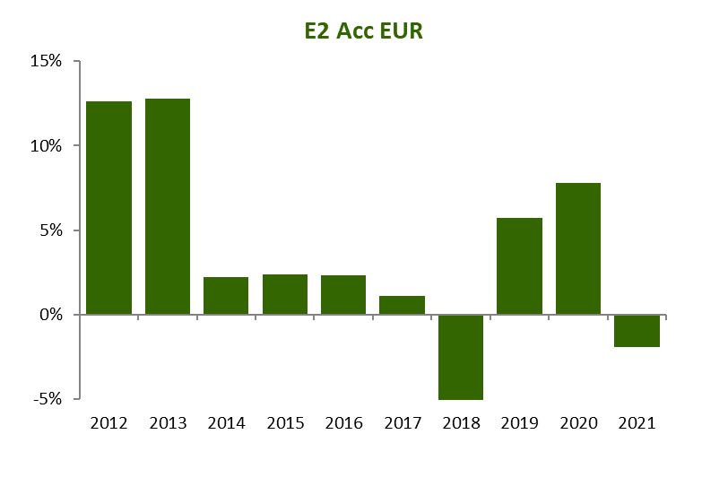

The past performance percentage reflected in the graphs above include all operating and management fees incurred by the Class E2 Accumulation Shares of the Fund. Past performance is not necessarily a guide to future performance, prices may fluctuate and you may not get back your original investment. As this fund is a newly-established receiving entity of a merger of a previous UCITS fund, past performance reflects the performance of Salar Fund PLC.

**Practical Information**



* Please note that the tax laws of Ireland may impact your personal tax position. You are advised to seek professional tax advice.
* The Manager may be held liable solely on the basis of any statement contained in this document that is misleading, inaccurate or inconsistent with the relevant parts of the Prospectus and/or the Supplement. The assets and liabilities of each sub-fund of the Company are segregated by Irish law.
* The Manager is authorised in Ireland and regulated by the Central Bank of Ireland.
* This key investor information relates to the class of shares (of the Fund) referenced in the title of the document. More specific information about the Company and the Fund, including how to buy, sell and switch shares, may be found in the Prospectus and the Supplement. The Prospectus, the audited annual report and accounts and the unaudited semi-annual report are prepared for the Company as a whole.

Information required, to the extent applicable, for Distribution of Foreign Collective Investment Schemes to Qualified Investors in Switzerland: The representative in Switzerland is Acolin Fund Services AG, Leutschenbachstrasse 50, CH-8050 Zurich, Switzerland. The distribution of Shares of the relevant CQS Fund in Switzerland will be exclusively made to, and directed at, qualified investors (the “Qualified Investors”), as defined in the Swiss Collective Investment Schemes Act of 23 June 2006, as amended (“CISA”) and its implementing ordinance (the “Swiss Distribution Rules”). Accordingly, the relevant CQS Fund has not been and will not be registered with the Swiss Financial Market Supervisory Authority ("FINMA"). The paying agent in Switzerland is Aquila & Co. AG, Bahnhofstrasse 28a, CH-8001, Zurich, Switzerland. The

relevant Offering Document and all other documents used for marketing purposes, including the annual and semi annual report, if any, can be obtained free of charge from the representative in Switzerland. The place of performance and jurisdiction is the registered office of the representative in Switzerland with regards to the Shares distributed in and from Switzerland. CQS (UK) LLP (as the distributor in Switzerland) and its agents do not pay any retrocessions to third parties in relation

to the distribution of the Shares of the relevant CQS Fund in or from Switzerland. CQS (UK) LLP (as the distributor in Switzerland) and its agents do not pay any rebates aiming at reducing fees and expenses paid by the relevant CQS Fund and incurred by the investors.The Company is authorised in Ireland and regulated by the Central Bank of Ireland. This key investor information is accurate as at **12 September 2022**

* A copy of the Company’s Remuneration Policy can be found at <https://www.cqs.com/documents/regulatory-disclosures/cqs_ucits_remuneration_policy.pdf>
* Details of the remuneration policy of the Manager are available at <https://kbassociates.ie> A paper copy of the remuneration policy will be made available free of charge upon request.
* The Depositary is BNP Paribas Securities Services, Dublin Branch.
* Information about the Fund and copies of the Prospectus, the Supplement, the latest audited annual report and accounts and any subsequent unaudited semi-annual report may be obtained in English, free of charge from the administrator, BNP Paribas Fund Administration Services (Ireland) Limited (the **Administrator**) or the investment manager, CQS (UK) LLP.
* Up-to-date subscription and redemption prices may be obtained from the Administrator.